**DATA COLLECTION INSTRUMENT - MEASURES**

**Variability in Pattern Practice**

Below are some example activities and questions for participants to complete during the session. All activities will be variants of the examples provided below.

Examples of pictures participants will see

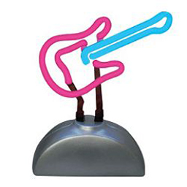

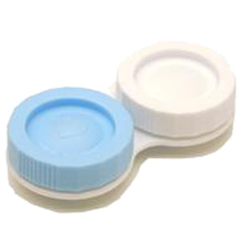



As shown in the sample pictures, they will be shown with daily life objects and try to recognize them later.